Emanon College Lab Build
Emanon College needs to double the number of computer labs and computers in the college, and update all of the lab equipment to current technology. The objective of this project is to build ten computer labs at Emanon before Fall classes start.

Project SCOPE
- Project documentation
- Lab design documents
- Ten computer labs
- Lab maintenance document

Project Schedule
Project start: 5 January
Duration: 8 months
Project finish: 28 August

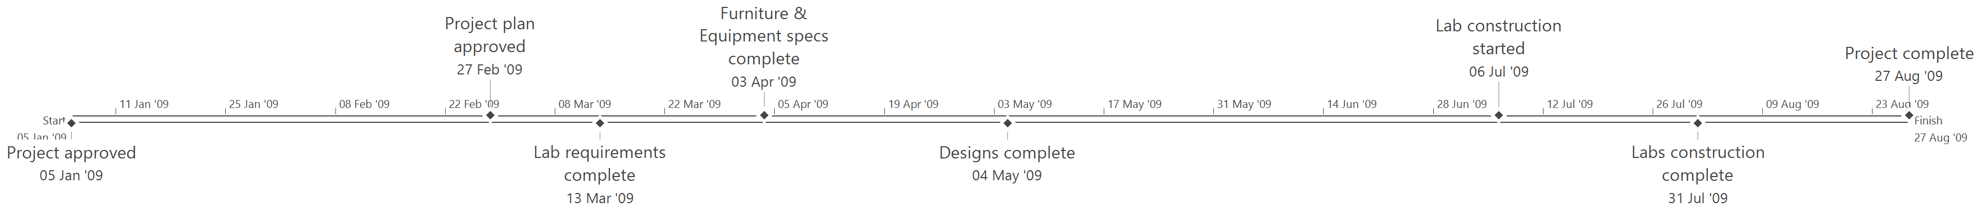

Project Budget
The total budget for this project is $1,665,000.

 | 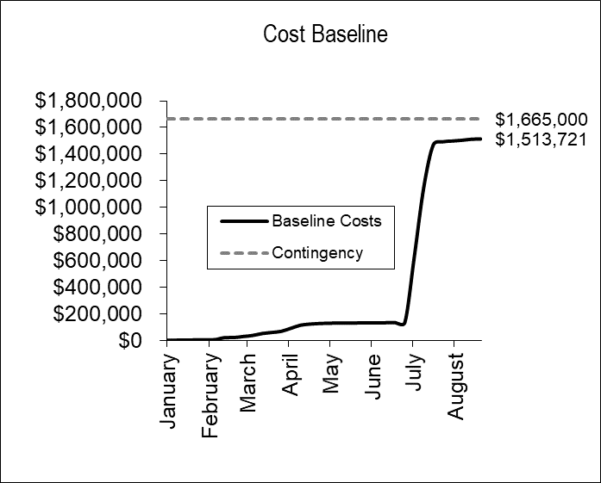
  Summary Tasks | Costs
  Project Management | $38,001
  Design | $101,120
  Construction
  Borlaug Building | $271,400
  Marquez Library | $271,400
  Salam Center | $407,100
  Sen Building | $407,100
  Commissioning | $17,600
  Sub-total | $1,513,721
  Contingency | $151,279
  Total | $1,665,000

Project Risk Management
The following table represents only the highest exposure risks on this project.

Risk Event | Exposure | Response Strategy
Project funding is reduced by more than 25% during project planning. | $75,000 | Establish full project funding approval as early as possible, with commitment to contracts as top priority.

